Connect with SSH
Validated on June 19, 2018 • Posted on June 19, 2018
DigitalOcean Droplets are managed using a terminal and SSH. You’ll need to have an SSH client and, optionally, an SSH key pair. Clients generally authenticate either using passwords (which are less secure and not recommended) or SSH keys (which are very secure and strongly recommended).
To log in to your Droplet with SSH, you need three pieces of information:
- The Droplet’s IP address
- The default username on the server
- The default password for that username, if you aren’t using SSH keys
To get your Droplet’s IP address, visit the DigitalOcean Control Panel. The IP address will be displayed in the IP Address column after your Droplet has been created. You can mouse over it to copy it into your clipboard.
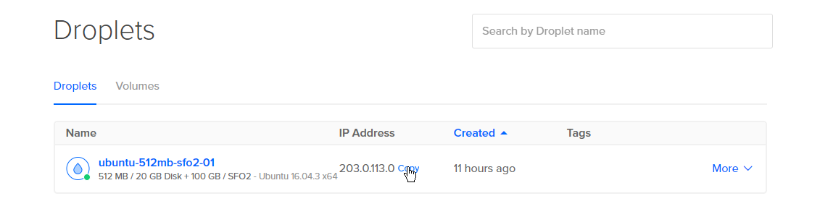
The default username is root on most operating systems, like Ubuntu and CentOS. Exceptions to this include CoreOS, where you’ll log in as core, Rancher, where you’ll log in as rancher, and FreeBSD, where you’ll log in as freebsd.
By default, the password for that user is randomly generated and emailed to you at your account’s email address. A password will not be generated and emailed if you have uploaded SSH keys to your account and chosen Add SSH Keys. Your key will be used automatically and you’ll be prompted for the key’s passphrase if you’ve set one.
Once you have your Droplet’s IP address, username, and password (if necessary), follow the instructions for your SSH client. OpenSSH is included on Linux and macOS. Windows users with Bash also have access to OpenSSH. Windows users without Bash can use PuTTY.

